Logging in to **Office 365** from home

Go to the Shivela Middle School website and click the Office 365 global icon

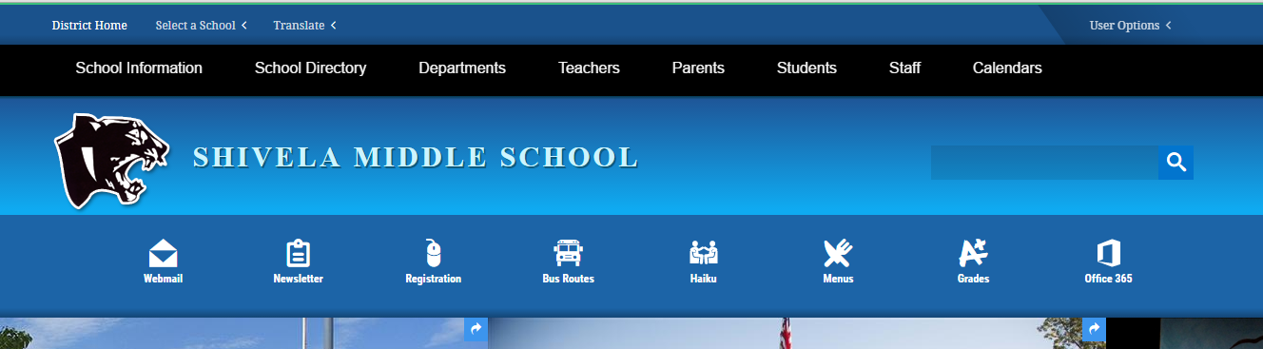

You will be redirected to the Office 365 login page

In the first line, please type your student email:

9-digit-number@student.murrieta.k12.ca.us

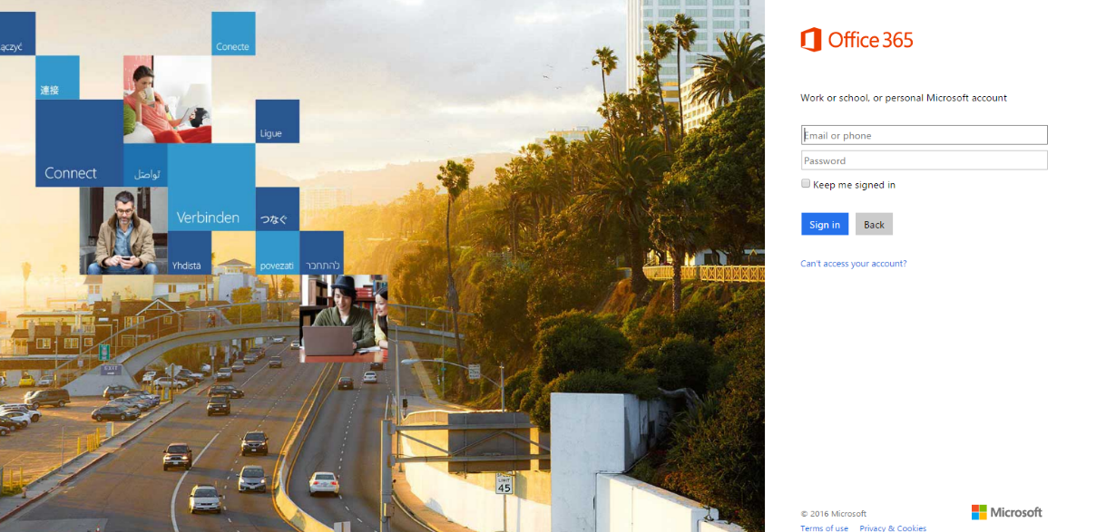

Then click the Password line and you will be redirected to a blue login screen

Type your Password used to login to the school computers

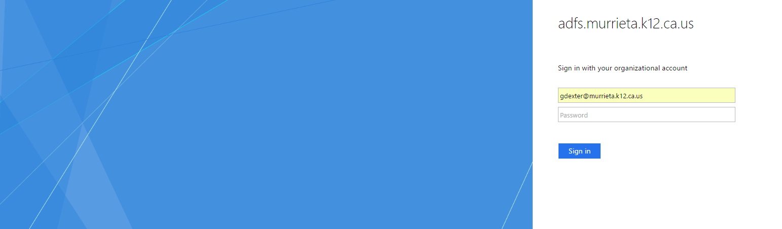

You should now be logged in to Office 365. The **OneDrive** is where you will save work so you can access it from school or another computer. You also have access to Microsoft word, PowerPoint and many other Microsoft programs.